Website Planning Document – Web Site “FurniCraft”

## Statement of Purpose & Goals

**Purpose:**  
Create an online platform that allows users to discover, design, and personalize unique furniture for their homes, combining creativity, 3D technology, and a seamless shopping experience.

**Objetives (SMART):**

|  |  |  |
| --- | --- | --- |
| **Objectives** | **Metrics** | **Timeframes** |
| Increase adoption of the configurator | ≥ 10,000 active users in the first 6 months | 6 months |
| Generating sales of customized furniture | Conversion > 5% and revenue volume > $250k | 12 months |
| Foster the creative community | Number of shared designs ≥ 2,000, NPS ≥ 70 | 12 months |
| Optimize the mobile experience | Mobile bounce rate ≤ 30% | 3 months |

## Definition of the Target Audience

The site targets those who value custom design and want practical furniture solutions tailored to their style and space.

| **Segments** | **Age** | **Profession / Lifestyle** | **Key needs** |
| --- | --- | --- | --- |
| Interior Designer | 25‑45 | Freelance, agencies | Quick tool for prototyping, exporting drawings |
| DIY & Makers | 20‑55 | Hobbyists, young professionals | Effortless customization, step-by-step tutorials |
| Homeowners | 30‑60 | Professionals / families | Fit to own space, quality guaranteed |

## People & Scenarios

### Personas

| **Name** | **Age** | **Occupation** | **Motivations** | **Pain Points** |
| --- | --- | --- | --- | --- |
| Elena – **Interior Designer** | 34 | Freelance | Differentiating, delivering visual proposals | Lack of easy and fast tools for prototyping |
| Carlos – **DIY enthusiast** | 27 | Engineer | Create unique pieces, learn new techniques | Difficulty visualizing results before buying |
| Mary – **Busy Mother** | 42 | Lawyer | Bespoke furniture to fit the family home | Limited time, fear of errors in custom orders |

### Scenarios

### **Elena creates a custom sofa**

* + Navigate to "Customize" → Select sofa base → Adjust dimensions → Choose upholstery and finish → Preview in AR → Add to cart → Buy with secure payment.

### **Carlos shares his design on social media**

* + Save project → Generate social link → Share on Instagram → Invite friends to see the 3D model → Receive comments and adjustments.

### **Maria reviews order history**

* + Log in → View "Order History" → Select previous order → Request a color adjustment → Send new request to customer service.

## Style Guide & Branding

### Brand Essence

* **Mission:** To empower users to create spaces that reflect their personality.
* **Values:** Creativity, Innovation, Quality, Sustainability.
* **Tone of Voice:** Inspiring and approachable; avoids unnecessary technical jargon.

### Logo and Usage

| **Element** | **Minimum Size** | **Clear Space** | **Correct Use** |
| --- | --- | --- | --- |
| Main Logo (FurniCraft) | 120 px (horizontal) / 60 px (vertical) | 1× the width of the logo in white/black | Always use on light backgrounds; Do not overlay text or images. |

### Typography Choices & Justification

| **Element** | **Font Family** | **Weight** | **Reason** |
| --- | --- | --- | --- |
| Headings (H1‑H6) | Montserrat – Sans‑serif | 700 / 600 | Modern, legible on a large scale; it transmits authority. |
| Body | Roboto – Sans‑serif | 400 | High on-screen readability, wide compatibility. |
| Captions / Small Text | Roboto Condensed – Sans‑serif | 300 | Save space without losing clarity. |

*Justification:* Both families are free (Google Fonts), which reduces costs and guarantees performance. Montserrat brings character to the mastheads, while Roboto keeps reading comfortable on mobile devices.

### Color Palette

| **Element** | **Hex** | | **Usage** |
| --- | --- | --- | --- |
| Primary – Deep marron | #862223 |  | Logo, Primary Buttons, Hover Links |
| Secondary – Vibrant red | #E63946 |  | Secondary CTAs, Error Alerts |
| Sections (intercalate) – Light grey | #f0f0f0 |  | General Fund, Cards |
| Text – Dark | black |  | Main text |
| Accent – Soft green | #205B36 |  | "Add to cart" buttons |
| Error – Light Red | #E74C3C |  | Error messages |

### Specific Styling of Elements

| **Element** | **CSS Example (Sass)** | **Notes** |
| --- | --- | --- |
| Headings (h1‑h6) | font-family: 'Montserrat', sans-serif; font-weight: 700; line-height: 1.2; color: black; margin-bottom: .5rem; | Maintain scalable sizes with rem. |
| Paragraphs | font-family: 'Roboto', sans-serif; font-size: 1rem; line-height: 1.6; color: black; margin-bottom: 1rem; | Enough space for reading. |
| Lists (ul, ol) | list-style-position: inside; padding-left: 0; | Use custom bookmarks based on context. |
| Forms (inputs, selects) | border: 1px solid #ccc; border-radius: .25rem; padding: .5rem 1rem; width: 100%; | Accessibility: :focus { outline: 2px solid $primary; }. |
| Links | color: $primary; text-decoration: none; &:hover, &:focus { text-decoration: underline; } | Sufficient contrast. |
| Buttons | font-family: 'Roboto', sans-serif; font-size: 1rem; background-color: var(--primary-color);color: white; border-ratio: 10px; padding: 0.5rem | The button style uses the Roboto font for a modern and clean look. It has a readable size of 1rem. The primary background color is high contrast with white text, which makes it accessible. Rounded corners are 10 px. Padding of 0.5rem gives the button enough space to click easily. |

## A site map

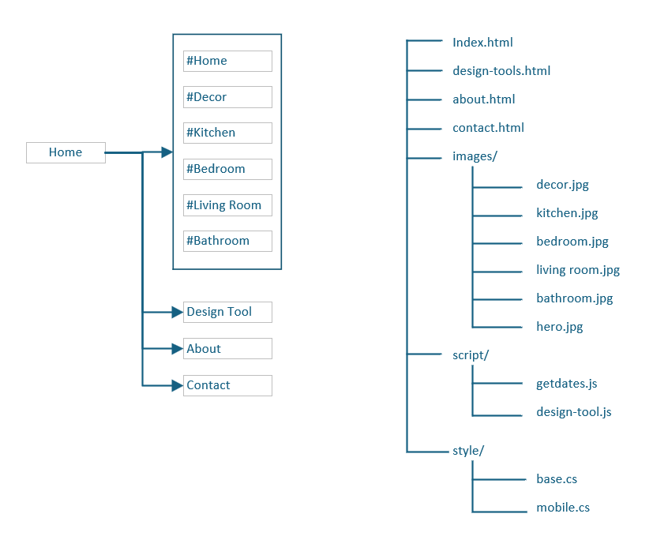

## Wireframes

### Mobile versions

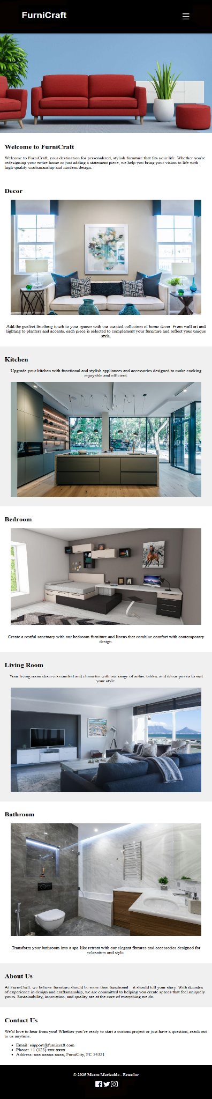

### Desktop version

### 